**Lesson 8 Demo 3**

**Creating a Docker Image**



Steps to be followed:

1. Creating the Dockerfile
2. Executing the Dockerfile

**Step 1: Creating the Dockerfile**

1.1 Create a directory

***mkdir demo***

***cd demo***

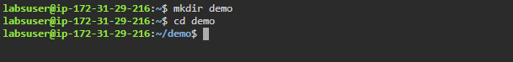

1.2 Create the Dockerfile

***vi Dockerfile***



1.3 Add the following code snippet to the Dockerfile

***FROM ubuntu***

***RUN apt-get update***

***RUN apt-get install -y nginx***

***COPY index.nginx-debian.html /var/www/html***

***CMD nginx -g 'daemon off;'***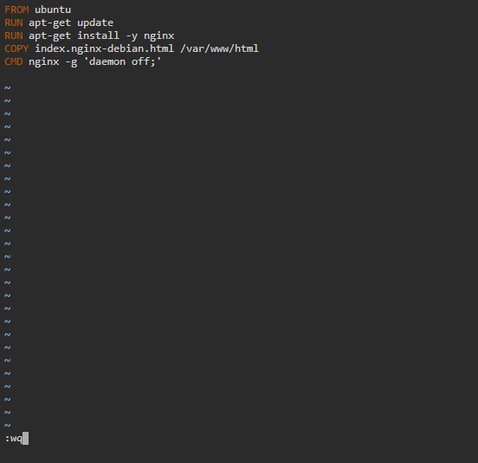



1.4 Create another file in the same directory

***vi index.nginx-debian.html***

1.5 Add the following welcome message to the index file ***WELCOME TO NGINX.***

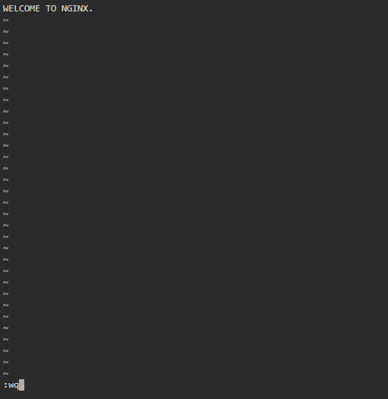



**Step 2: Executing the file**

2.1 Execute the Dockerfile (note that there is space between **build** and **“.”**)

***sudo docker build*** 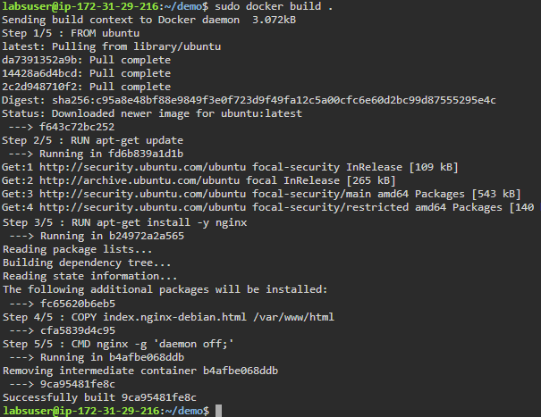

2.2 Navigate to the root folder, and list the images to check the newly created Docker image

***cd***

***sudo* *docker images***